**Name: Nguyen Xuan Binh**

**Student ID: 887799**

**Fracture Mechanics Final Exam**

From the beam theory of cantilever maximum displacement, we have:

, where L is the length of the beam and  is maximum displacement

For the upper arm of the component, we have:

* Inertia: 
* Compliance:  (answer)

For the lower arm of the component, we have:

* Inertia: 
* Compliance:  (answer)

The compliance of the whole system is

 (answer)

The energy release rate of the whole component system is



*  (answer)

Under displacement control, the energy release rate is:



Assuming that the material has a flat R-curve, crack growth is unstable under displacement control because of  (answer)

According to the formula in of fracture toughness:

 (answer)

The aluminum plate is thin => The plane stress condition is assumed

Therefore, the plastic zone size under plane stress is:



If the plastic zone size  is roughly an order of magnitude smaller than the crack length (), we conclude that Linear Elastic Fracture Mechanics (LEFM) applies, and fracture will occur when . Since , LEFM can be applied here.

The stress intensity factor when the fracture stress is increased to  becomes:



By principal of superposition, the fracture toughness with wire reinforcement becomes

, where negative sign of  indicates compression on the aluminum plate

* 

The stress intensity induced by the wire is:

, which is a reduced formula from  where 

* 

The force P needed to increase fracture stress to  is  (answer)

The plate is thin and large => The plane stress condition is assumed. The energy release rate is

* 

The moment at which fracture will become unstable is when:

(I)  and (II) 

The first condition gives us:

 (I)

Whereas the second condition returns:

 =>  (II)

Combining two equations, we have the following equality:

 => 

* => 
* . Replace  into the equation
*  => 

Therefore, the amount of stable crack growth is  (answer)

We can substitute the stable crack growth into the second equation to obtain the critical stress



* 

Therefore, the stress at which unstable fracture occurs is  (answer)

The stress field in the global reference frame is:



The first and second points on the Mohr circle are:  and 

* The two points are  and 

The Mohr’s circle for this stress field is:

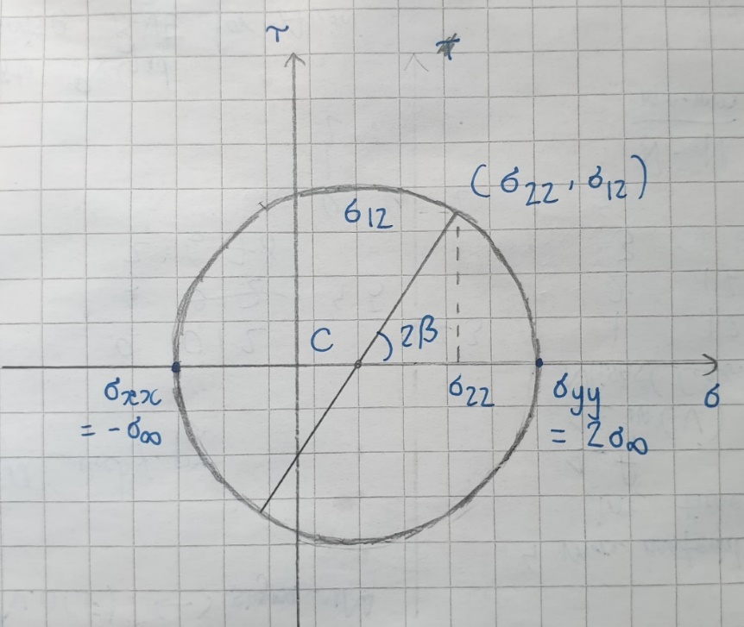

where the center C and radius R of the circle are:  and 

The stresses  and  in the local reference frame are given by:

  


Finally, the stress intensity factors as a function of and  are given by:

 (answer)

To find the angle of crack propagation, we set , and this gives:



* 

We are also given the information that 

* . Let . Replace this into the equation
* 

We can apply these two identities to simplify the equation

* 
* 
* 
* 

Plot the trigonometric function in MATLAB and we can observe that it has six roots in . Now we can use numerical solutions to find the six roots of the function

The correct angle  is the one corresponding to the maximum 



We are also given the information that , so we need to maximize this quantity



Plugging the solutions above:

=>  => 

=>  => 

=>  => 

Therefore, it shows that  corresponds to a maximum . Therefore, the crack will propagate along (answer)